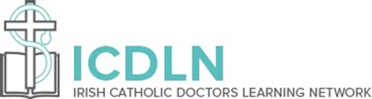

ICDLN 6th Annual Conference, Saturday, 2nd October 2021
Venue: Online Only
The Art of Dying Well – Clinical and Pastoral Perspectives

09:45 Welcome & Introduction – Dr. Keith Holmes, President, ICDLN
Opening Prayer – Fr Paul Francis Spencer CP, Chaplain, ICDLN

10:00 Prof. Ilora Baroness Finlay of Llandaff
Professor of Palliative Medicine, Member of the House of Lords
“Dignity and issues around Assisted Suicide and Euthanasia.”
10:45 Fr. John Kelly,
Chaplain & Director of Pastoral Care, Tallaght University Hospital
“Experience of Chaplaincy Services during the Covid Pandemic.”
11:30 Break – Tea/Coffee
12:00 Prof. David Albert Jones
Fellow, Director of the Ansombe Bioethics Centre
“The Ethics of 'Assisted Dying': Respect for Life, Acceptance of Death, Freedom of Conscience and Suicide Prevention”
13:00 Lunch Break
14:00 Dr Miriam Colleran
Consultant in Palliative Medicine, St. Brigid's Hospice & Naas Hospital, Co. Kildare
“Assisted Dying - the Naming of Assisted Suicide and Euthanasia & where we are now.”
15:00 Bishop Brendan Leahy, Bishop of Limerick
“Spirituality in Healthcare.”
16:00 Closing Remarks and End
Further information and on-line registration: www.icdln.ie

